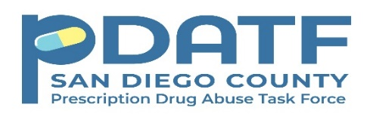

Prescription Drug Abuse Task Force
Quarterly Meeting Schedule

2020/21 Fiscal Year

Quarterly Meeting – Open to ALL Interested
** Meetings are virtual until further notice**
August 21, 2020 9:00 AM – 11 AM
November 20, 2020 9:00 AM – 11:00 AM
February 19, 2021 9:00 AM – 11:00 AM
May 21, 2021 9:00 AM – 11:00 AM

